**This is a practice worksheet for Economic concepts, PPF and gains from trade. Notice that some of the questions do not have solutions. Try them out on your own, and if you run into problems, feel free to ask the student tutors for help. Best of luck!**

**Economic concepts, PPF and gains from trade**

**Q1)** Alice has found herself on a desert island and must gather supplies to survive. Alice has 8 hours of useful stamina that she can use towards gathering firewood or coconuts. She finds that she can gather 1 bundle of firewood every two hours, or 6 coconuts every 4 hours.

1. In terms of a number of coconuts, what is the opportunity cost of 1 bundle of wood? What is the opportunity cost of 12 coconuts in terms of bundles of wood?
2. Bob just crash landed on the island too. He doesn’t have quite the stamina that Alice does so he can only work 6 hours a day. He finds that he can gather a bundle of wood in 2 hours or 1 coconut per hour. What is his opportunity cost for 1 bundle of wood? What is the opportunity cost of 6 coconuts in terms of bundles of wood?
3. Who has the absolute advantage in the production of firewood and coconuts, respectively? (In this case, we will say a person has the absolute advantage in the production of a good if he or she produces more when devoting all available resources to the production of that good, so compare Alice spending all 8 of her hours on each with Bob spending all 6 of his hours.)

**Q1 Solution**

(a) In the amount of time it takes to gather a bundle of firewood, Alice could have gathered (½)* 6 = 3 coconuts. Thus, the opportunity cost of one bundle of firewood is 3 coconuts. The opportunity cost of 12 coconuts is 4 bundles of firewood: Alice can gather 12 coconuts in 8 hours. If she were to gather firewood instead during these 8 hours then she would be able to gather 4 bundles of firewood: hence, when she chooses to gather 12 coconuts she is giving up 4 bundles of firewood.

(b) Each bundle of firewood takes as long as gathering 2 coconuts, so the opportunity cost of one bundle of firewood is 2 coconuts. The opportunity cost of 1 coconut is 1/2 bundle of firewood. So, for 6 coconuts, his opportunity cost is (½)* 6 = 3 bundles of firewood.

(c) Alice has absolute advantage in the production of both goods since she can out-gather Bob in both if she devotes all her time to one or the other. Bob has a comparative advantage in gathering firewood since each bundle of wood only costs him 2 coconuts compared to 3 for Alice. Alice then has comparative advantage in coconuts since she can gather 3 coconuts at a cost of 1 bundle of wood, but Bob can only gather 2 coconuts at a cost of 1 bundle of wood.

**Q2)**

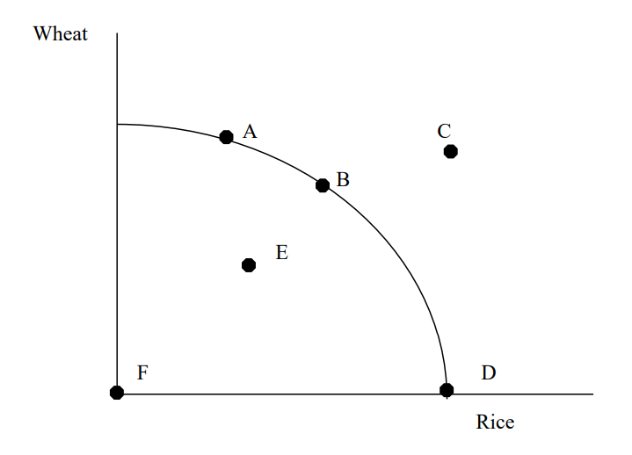

1. Which point(s) in this economy that produces wheat and rice production are the most efficient and why?
2. As the economy moves from point D to B to A, what happens to the opportunity cost of wheat?
3. Identify the point in the diagram which is unattainable and state the reason.
4. Identify the inefficient point(s) in the diagram and explain why.

**Q2 solution**

1. A, B and D since these points lie on the PPF curve.
2. Opportunity cost is increasing
3. C as it lies outside the PPF curve which is not reachable with current resources and without an improvement in technology.
4. F and E since they are inside the PPF and the resources are not being fully employed.

**Q3.** In 30 minutes, Kana can either make miso soup or she can clean the kitchen. In 15 minutes, Mitchell can make miso soup; it takes Mitchell an hour to clean the kitchen. Fill in the blanks.

i.Mitchell has the absolute and comparative advantage at __________.

ii. Kana has the absolute and comparative advantage at ____________.

**Q3 Solution**

(i) making miso soup

(ii) cleaning the kitchen

**Q4.** Data can write 12 excellent poems per day or solve 100 difficult physics problems per day. Riker can write one excellent poem per day or solve 0.5 difficult physics problems per day.

**Q4 solution:**   
Data has the absolute and comparative advantage at solving physics problems.

**Q5:**

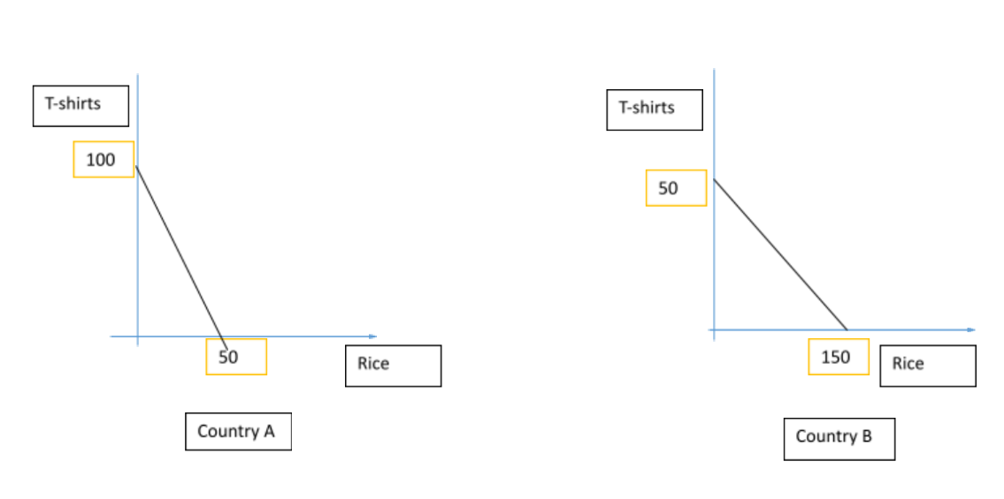

The graphs show two countries: Country A and Country B. Both countries produce T-shirts and Rice.

If country A utilizes all of its labor power and machine power in the production of T-shirts, it can produce 100 of them by sacrificing the production of 50 kilos of rice. Whereas if Country B utilizes all of its labor and machine power in T-shirt production, it is able to produce 50 of them while giving up 150 kilos of rice.

Strictly based on the comparative advantage theory, determine which country is the most efficient in rice production and which in T-shirt production. Should Country A specialize in rice production? Explain why or why not.

**Q6:**

Use the figure below to answer the following question. Assume that the Canadian agricultural land is used either to raise cattle for beef or to grow wheat. The figure below represents the production possibility frontier for beef and wheat. Determine the opportunity cost of moving from

1. F to G
2. G to F

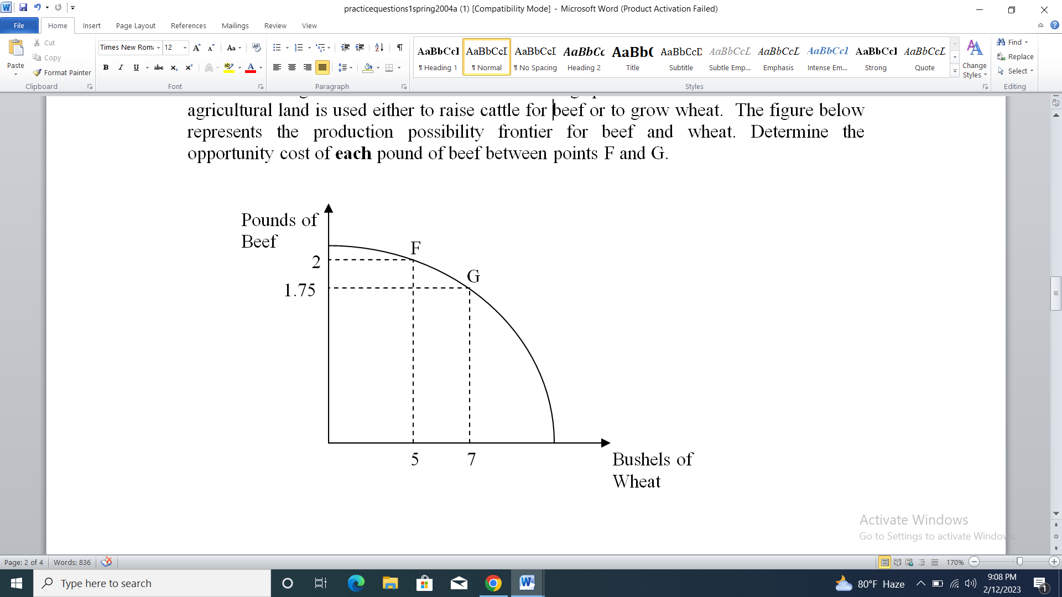

**Q7:**

Sarah and James are siblings. Their parents want 12 windows on the house washed and the 25 square yards of leaves raked. Sarah and James estimate their output as shown in the following table.

|  | Windows per hour | Square yards of leaves per hour |
| --- | --- | --- |
| Sarah | 4 | 6 |
| James | 3 | 5 |

1. Is Sarah going to specialize in raking leaves? Why or why not?
2. How long will Sarah and James take in doing the job if they specialize according to their comparative advantages?